EN110 notes

Capacity factor: Unitless ratio of electrical energy output over a given period of time to the maximum electrical energy output over that period (continuous operation at full nameplate capacity over the relevant period assumed).

The **load factor** is defined as the average load divided by the peak load in a specified time period.[[1]](https://en.wikipedia.org/wiki/Load_factor_(electrical)#cite_note-1) It is a measure of the utilization rate, or efficiency of electrical energy usage

(power/electricity consumed)

Energy footprint: Energy or power needed to make the given device.

Installed capacity or nameplate capacity is the intended full-load sustained output of a facility.

Efficacy - ability to produce a desired result.

Low quality energy - dispersed and disorderly, less potential or ability to be utilised for work. Generally comes with a lot of heat loss or high temperature. Eg, thermal energy.

Eg of high quality energy - electrical energy, etc. Mechanical energy is high quality as it can be converted to electrical with great efficiency.

Human Disruption Index (DI) = Ratio of Human generated flow of a given pollutant to the natural or baseline flow (SO2, NOx, CO, SPM, CO2, CFC, ….)

A pyrheliometer is an instrument for measurement of direct beam [solar irradiance](https://en.wikipedia.org/wiki/Solar_irradiance).

Sunlight enters the instrument through a window and is directed onto a [thermopile](https://en.wikipedia.org/wiki/Thermopile) which converts heat to an electrical signal that can be recorded. The signal voltage is converted via a formula to measure watts per square metre.

A pyrheliometer is often used in the same setup with a [pyranometer](https://en.wikipedia.org/wiki/Pyranometer).

A pyranometer is a type of [actinometer](https://en.wikipedia.org/wiki/Actinometer) used for measuring [solar irradiance](https://en.wikipedia.org/wiki/Solar_irradiance) on a planar surface and it is designed to measure the solar radiation [flux density](https://en.wikipedia.org/wiki/Flux_density) (W/m2) from the hemisphere above within a wavelength range 0.3 μm to 3 μm.

The tragedy of the commons is a term used in social science to describe a situation in a shared-resource system where individual users acting independently according to their own self-interest behave contrary to the common good of all users by depleting or spoiling that resource through their collective action.

Payback Period = Initial Investment/ Annual Savings

Payback period:

the length of time required for an investment to recover its initial outlay in terms of profits or savings.

**Global warming potential** (**GWP**) is a measure of how much heat a [greenhouse gas](https://en.wikipedia.org/wiki/Greenhouse_gas) traps in the atmosphere up to a specific time horizon, relative to [carbon dioxide](https://en.wikipedia.org/wiki/Carbon_dioxide). It compares the amount of heat trapped by a certain mass of the [gas](https://en.wikipedia.org/wiki/Gas) in question to the amount of heat trapped by a similar mass of [carbon dioxide](https://en.wikipedia.org/wiki/Carbon_dioxide) and is expressed as a factor of carbon dioxide (whose GWP is standardized to 1).

- GWP CO2 =1

- CH4 =28

- N2O = 265 (AR5)

Emission factor - emission per unit of useful output.

kg CO2/kWh

Isentropic process - adiabatic and reversible

Capital recovery factor:

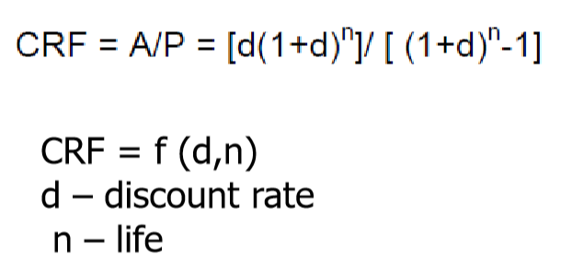

The capital recovery factor is a ratio used to calculate the [present value](https://www.homerenergy.com/products/pro/docs/3.11/present_value.html) of an annuity (a series of equal annual cash flows).

For i = 7% and N = 5 years, the capital recovery factor is equal to 0.2439. A $1000 loan at 7% interest could therefore be paid back with five annual payments of $243.90. The [present value](https://www.homerenergy.com/products/pro/docs/3.11/present_value.html) of the five annual payments of $243.90 is $1000.

Nominal - theoretical, existing in name only.

Dose effectiveness - gram/tonne in the air of pollutant going into the lungs.

-Kaya identity: Total CO2 Emissions = (CO2/E)(E/GDP)(GDP/Pop)Pop

The Kaya identity is an [identity](https://en.wikipedia.org/wiki/Identity_(mathematics)) stating that the total emission level of the [greenhouse gas](https://en.wikipedia.org/wiki/Greenhouse_gas) [carbon dioxide](https://en.wikipedia.org/wiki/Carbon_dioxide) can be expressed as the product of four factors: human [population](https://en.wikipedia.org/wiki/World_population), [GDP](https://en.wikipedia.org/wiki/GDP) [per capita](https://en.wikipedia.org/wiki/Per_capita), [energy intensity](https://en.wikipedia.org/wiki/Energy_intensity) (per unit of GDP), and [carbon intensity](https://en.wikipedia.org/wiki/Carbon_intensity) (emissions per unit of energy consumed).

CO2/E – Carbon Intensity

E/GDP- Energy Intensity of Economy

-Total SO2 Emissions = (SO2/E)(E/GDP)(GDP/Pop)Pop

SO2/E – Emissions factor

E/GDP- Energy Intensity of Economy

-Emissions = EF×En Int ×(GDP/POP) ×POP

Reduce EF

Reduce Energy Intensity

In electrical engineering the load factor is defined as the average load divided by the peak load in a specified time period. It is a measure of the utilization rate, or efficiency of electrical energy usage

An emission intensity is the emission rate of a given pollutant relative to the intensity of a specific activity, or an industrial production process; for example grams of carbon dioxide released per megajoule of energy produced.

 An electrical ballast is a device placed in line with the load to limit the amount of current in an electrical circuit. It may be a fixed or variable resistor.

A carbon footprint is historically defined as the total emissions caused by an individual, event, organization, or product, expressed as carbon dioxide equivalent.

In systems involving heat transfer, a condenser is a device or unit used to condense a substance from its gaseous to its liquid state, by cooling it. In so doing, the latent heat is given up by the substance and transferred to the surrounding environment.

Subcooled liquid - liquid through pressure, despite being at a higher temperature

Wet stream - ms = mass of steam, ml = mass of liquid

Superheated steam - above boiling point at that temperature

Supercritical - pressure and temperature are above critical point.

Question - e). Temperature and pressure can be water, steam, anything.

X = (h -hf)/(hs - hf)

The critical temperature of a substance is the **temperature at and above which vapor of the substance cannot be liquefied**, no matter how much pressure is applied. Every substance has a critical temperature.

Saturated liquid - 100% liquid at its boiling point.

Saturated steam - 100% vapour at the boiling point

Wet steam is a **mixture of steam and liquid water**. It exists at a saturation temperature containing **more than 5% water**. It is said to be a two-phase mix: steam contains droplets of water that have not changed phase.

*Wet Steam (Dryness fraction x =ms/ms+ml)*

**Superheated steam** is a [steam](https://en.wikipedia.org/wiki/Steam) at a temperature higher than its vaporization (boiling) point at the absolute pressure where the temperature is measured.

UNITS OF ENERGY - POWER OF 10

Joule - 0

Megajoule - 6

Gigajoule - 9

Tetrajoule - 12

Petajoule - 15

Exajoule - 18

BTU - British thermal unit - amount of heat required to raise the temperature of one pound of water by one degree fahrenheit.

Coal is expected to last for another 125 years.

India: expected life of different energy resources-

Coal: 83 years

Oil - 23 years

N gas - 29 years

Uranium - 50 years

Ways to reduce carbon emissions:

Sinks - energy absorbers.

Carbon sequestration is the process involved in carbon capture and the long-term storage of atmospheric carbon dioxide or other forms of carbon to mitigate or defer global warming.

•Mitigation – increase sinks, afforestation, fuel mix, energy efficiency, renewables, carbon sequestration

LPG Stove:

Calculation of thermal efficiency of a stove:

Efficiency E = 100x (G+W)(t2-t1)/MK

G – quantity of water in kg

W-water equivalent of vessel with stirrer and lid

M- gas consumption in kg

K- calorific value of gas in kcal/kg

Performance parameters:

-Power output

-Burner rating – kcal/ hour

-Time taken

-Gas flow rate g/hr

-Efficiency

-CO

-NOx

-Life

-Capital cost

-Operating cost

Solar box cookers typically cook food at temperatures between 90 °C (194 °F) and 200 °C (392 °F).

Parabolic solar cookers use a parabolic-shaped reflector to direct sunlight to a small area in order to generate heat for cooking. They are able to reach high temperatures, 350 °C (662 °F) or higher, which allows them to be used for grilling and frying.

Incoming radiation - Ig

Incoming power - Ig * surface area of aperture (Qin)*constant = Ig*Aap*c

Qloss- heat loss = U*Ar*(Tr - Tamb) (power loss)

U = coeff of heat loss

Ar = area of receiver

Tr - temperature of receiver

Tamb = ambient (room) temperature

F = Qin/Qloss

This ratio should be increased.

Qu (useful power) = Qin - Qloss

Wait until temperature of water is constant. When in it in its stagnant state, Qin = Qloss.

By measuring (Tr-Tamb), we can find the ratio of Ig*Aap*c/U*Ar

THERMODYNAMICS:

Isolated system - neither energy nor mass

Closed – energy, but no mass

Open - both energy and mass are exchanged

Heat goes in doing work and raising the internal energy of the system.

Heat supplied at constant volume - internal energy

Heat supplied at constant pressure – enthalpy

If a system is going in a cycle: The heat absorbed by the system = work done by the system during the cycle.

The change in energy of the system (E1-2) is the heat added to the system (Q1-2) minus the work done by the system (W1-2).

The first law of thermodynamics can also be stated in terms of negation of a perpetual motion machine. It is not possible to construct a device which operates in a cycle and delivers a net work output as the sole effect. Heat must be absorbed.

Enthalpy of a substance: H = U + PV

Kelvin Planck - It is not possible to construct a process whose sole effect is the absorption of heat from a reservoir and the conversion of this heat to work. You cannot build a heat engine which has 100% thermal efficiency.

In other words: “It is impossible to construct a device which operates on a cycle and produces no other effect than the production of work and the transfer of heat from a single body”.

The Kelvin–Planck statement does not exclude the existence of a system, that develops a net amount of work from a heat transfer extracted from a thermal reservoir. According to this statement, a system undergoing a cycle cannot develop a positive net amount of work from a heat transfer extracted from a thermal reservoir.

Clausius Statement-

No process is possible whose sole effect is the transfer of heat from a colder to hotter body viz. No spontaneous transfer of heat from colder to hotter body.

In other words:

Heat cannot spontaneously flow from cold system to hot system without external work being performed on the system. This is exactly what refrigerators and heat pumps accomplish.

Carnot Efficiency:

limits on the maximum efficiency any heat engine can obtain. In short, this principle states that the efficiency of a thermodynamic cycle depends solely on the difference between the hot and cold temperature reservoirs.

Carnot’s principle states:

1. No engine can be more efficient than a reversible engine (a Carnot heat engine) operating between the same high temperature and low temperature reservoirs.
2. The efficiencies of all reversible engines (Carnot heat engines) operating between the same constant temperature reservoirs are the same, regardless of the working substance employed or the operation details.

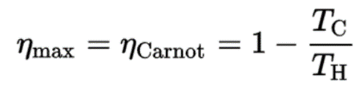

It must be added, this is an idealized efficiency. The Carnot efficiency is valid for reversible processes. These processes cannot be achieved in real cycles of power plants.

 A reservoir is a large object, in which the temperature remains constant while energy is extracted.

One consequence of the second law of thermodynamics is the development of the physical property of matter, that is known as the [entropy (S)](https://www.nuclear-power.net/nuclear-engineering/thermodynamics/what-is-energy-physics/what-is-entropy/). The change in this property is used to determine the direction in which a given process will proceed. Entropy quantifies the energy of a substance that is no longer available to perform useful work. This relates to the second law since the second law predicts that not all heat provided to a cycle can be transformed into an equal amount of work, some heat rejection must take place.

The second law of thermodynamics can also be expressed as ∆S≥0 for a closed cycle.

Entropy tells us about the usefulness of a quantity of transferred heat in performing work.

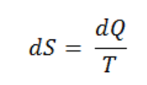

Tonnes of Refrigeration

Historically TR – used as unit for refrigeration

Amount of heat transfer (cooling) required to make one short ton of ice (2000 lbs) from water at 0 C in one day

ENERGY AND ENVIRONMENT

There's more carbon dioxide in the winter and a bit less in the summer. That's the collective breathing of all the plants in the Northern Hemisphere. "Plants are accumulating carbon in the spring and summer when they're active, and they're releasing carbon back to the air in the fall and winter

WATER WHEELS

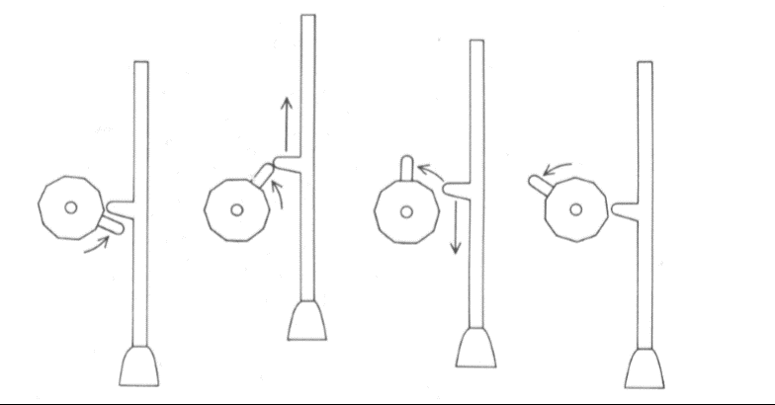

Overshot water wheel.

Overshot waterwheel with canted vanes (bucket separators). As the cant angle φ increases, water is retained for longer, increasing torque.

(water passes from above its axle)

Horizontal wheel has blades attached to a moving rotor.

CENTRIFUGAL PUMPS:

Centrifugal pumps are used to transport fluids by the conversion of rotational kinetic energy to the hydrodynamic energy of the fluid flow. The rotational energy typically comes from an engine or electric motor. The fluid enters the pump impeller along or near to the rotating axis and is accelerated by the impeller, flowing radially outward into a diffuser or [volute](https://en.wikipedia.org/wiki/Volute_(pump)) chamber (casing), from where it exits.

The fluid gains both velocity and pressure while passing through the impeller. The doughnut-shaped diffuser, or scroll, section of the casing decelerates the flow and further increases the pressure.

WIND MACHINES

Wind Data:

- Wind Velocity- horizontal component measured

- Anemometer- Hourly speed tabulated

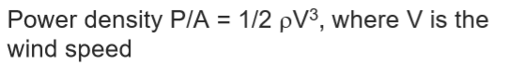

-Cut-in Speed- Minimum wind speed at which power is produced

- Design Speed- Wind speed for rated output

- Cut-Out (Furling ) Speed - Speed at which m/c needs to be shut down to avoid damage

Wind turbine characteristics:

Power Coefficient (Cp) - Ratio of the power extracted by the rotor to the power available in the wind stream

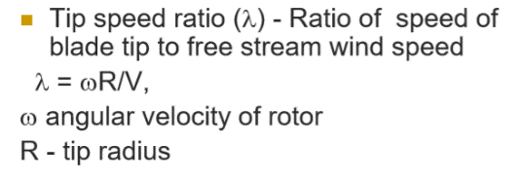

Turbine parameters:

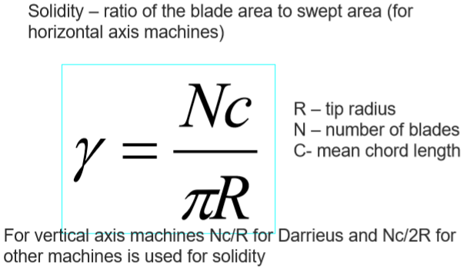

Wind speed varies with height from ground:

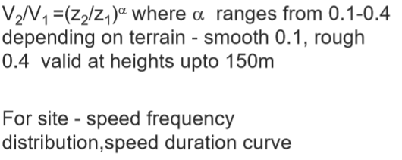

**Betz's law** indicates the maximum power that can be extracted from the wind, independent of the design of a [wind turbine](https://en.wikipedia.org/wiki/Wind_turbine) in open flow. It was published in 1919, by the German physicist [Albert Betz](https://en.wikipedia.org/wiki/Albert_Betz).

According to Betz's law, no turbine can capture more than 16/27 (59.3%) of the [kinetic energy](https://en.wikipedia.org/wiki/Kinetic_energy) in wind. The factor 16/27 (0.593) is known as Betz's coefficient. Practical utility-scale wind turbines achieve at peak 75% to 80% of the Betz limit.

CENTRIFUGAL PUMP/POWER STATIONS:

Centrifugal pumps are used to transport fluids by the conversion of rotational kinetic energy to the hydrodynamic energy of the fluid flow. The rotational energy typically comes from an engine or electric motor. The fluid enters the pump impeller along or near to the rotating axis and is accelerated by the impeller, flowing radially outward into a diffuser or [volute](https://en.wikipedia.org/wiki/Volute_(pump)) chamber (casing), from where it exits.

The fluid gains both velocity and pressure while passing through the impeller. The doughnut-shaped diffuser, or scroll, section of the casing decelerates the flow and further increases the pressure.

Performance measurement:

- Head (m) or Pressure developed (kPa)

- Flow rate (kg/s – mass or volumetric – m3/hr)

- Fluid – density

- Efficiency

- Input power

- Speed - RPM

Power Station components

- Power Transformers

- Capacitor Banks

- Circuit Breakers

- Bus

- Relays

Performance parameters of a power plant:

Heat rate (energy efficiency)

Thermal efficiency

Capacity factor

Load factor

Economic efficiency

Operational efficiency

A **tap changer** is a mechanism in [transformers](https://en.wikipedia.org/wiki/Transformer) which allows for variable turn ratios to be selected in discrete steps. And with this mechanism obtain this variable turn ratio by connecting to a number of access points known as **taps** along either the primary or secondary winding.

On load tap changers alter the turn ratios of the transformer on the system by altering the number of turns in one winding of the appropriate transformer.

STEAM ENGINE:

A **steam engine** is a [heat engine](https://en.wikipedia.org/wiki/Heat_engine) that performs [mechanical work](https://en.wikipedia.org/wiki/Mechanical_work) using [steam](https://en.wikipedia.org/wiki/Steam) as its [working fluid](https://en.wikipedia.org/wiki/Working_fluid). The steam engine uses the force produced by steam pressure to push a piston back and forth inside a cylinder. This pushing force is transformed, by a [connecting rod](https://en.wikipedia.org/wiki/Connecting_rod) and [flywheel](https://en.wikipedia.org/wiki/Flywheel), into [rotational](https://en.wikipedia.org/wiki/Rotation) force for [work](https://en.wikipedia.org/wiki/Work_(physics)).

Enthalpy-entropy diagram for water-steam

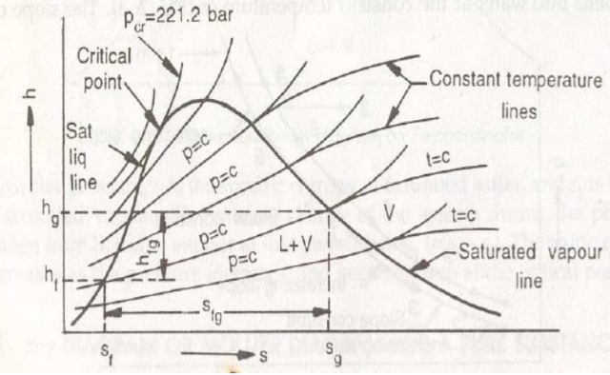

Pressure-enthalpy:

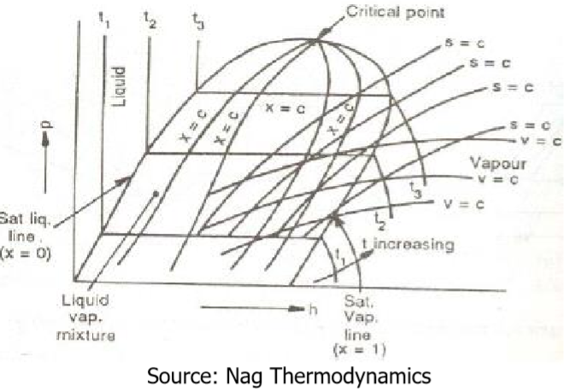

Temperature-entropy:

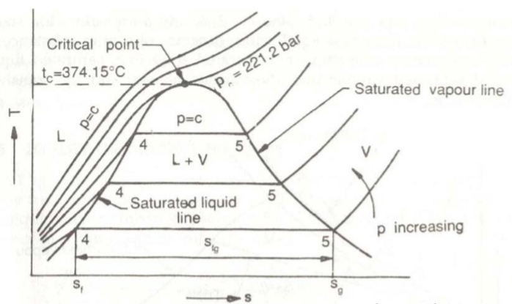

AC CURRENT:

Frequency for AC current - 50 Hz for India

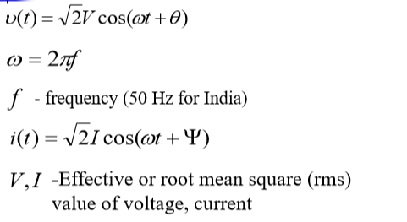

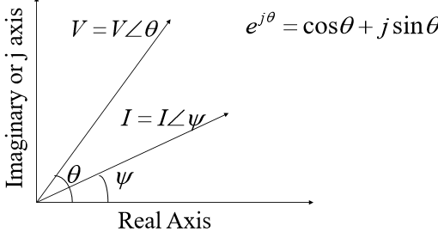

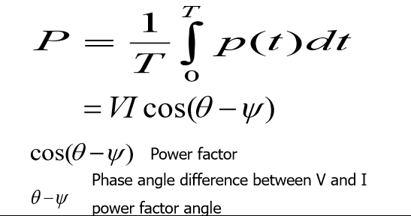

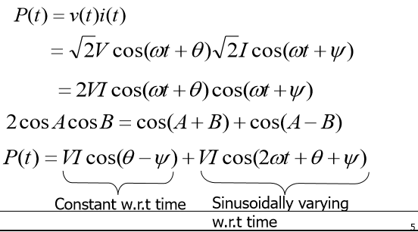

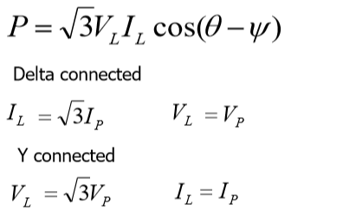

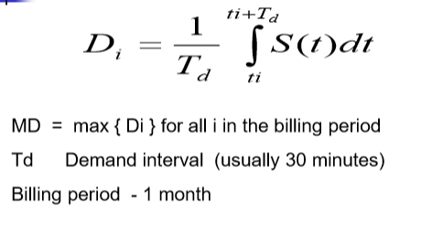

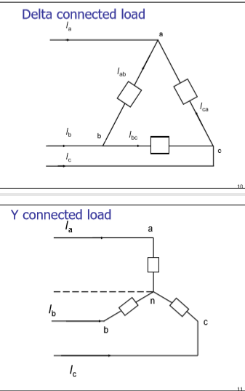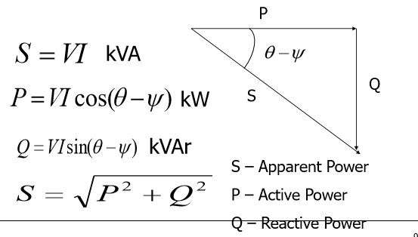

LATENT HEATS/CALORIFIC VALUES

Water: Latent heat of fusion 333.6 kJ/kg (79.7kcal/kg)

CONVERSIONS

1 kg ~ 2.2 lbs (1 TR = 3.5 kW)